Task -3:

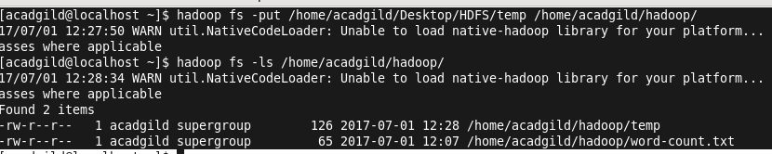

Task- 4:

Changing permission using chmod

